NAME :G.AKSHAYA COURSE CODE : CSA0619
REG NO: 192521156 COURSE NAME : DESIGN AND ANALYSIS OF ALGORITHMS

CO4 - ASSESSMENT TOOL – 01

Q2. Unbounded Knapsack
Aim:

To apply the Dynamic Programming technique to solve the Unbounded Knapsack problem, where each type of item can be selected multiple times without restriction. The objective is to maximize the total profit while ensuring that the total weight does not exceed the given knapsack capacity.

Problem Statement:

A manufacturing unit produces different types of items. Each item has a specific weight and profit. An unlimited number of each type of item is available, meaning the same item can be selected multiple times.

Given the weights, values, and maximum capacity of the knapsack, the objective is to determine the combination of items that produces the maximum possible profit without exceeding the available capacity.

The problem differs from the 0/1 Knapsack problem because in 0/1 Knapsack each item can be selected at most once, whereas in Unbounded Knapsack, the same item can be selected any number of times.

Dynamic Programming is used because the problem contains overlapping subproblems and optimal substructure.

Objective:

Maximize the total profit.

Allow unlimited selection of every item.

Ensure the total weight does not exceed the given capacity.

Apply Dynamic Programming to solve the problem efficiently.

Avoid unnecessary repeated calculations.

Determine the optimal combination of items.

Analyze the time and space requirements of the algorithm.

Verify the maximum profit using the given sample input.

Dynamic Programming Approach :
Let:
dp[w] = Maximum profit that can be obtained with capacity w
Initially, all values of the DP array are set to zero because a capacity of zero gives zero profit.
For every capacity from 1 to W, each item is checked.
If the weight of an item is less than or equal to the current capacity, the following recurrence is used:
dp[w] = max(dp[w], value[i] + dp[w - weight[i]])
The important point is that the item can be selected again. Therefore, the DP array uses the already calculated value dp[w - weight[i]].
Why Unbounded Knapsack?
In this problem, items are reusable.
For example, Item 2 has:
Value = 30
Weight = 10
Since the capacity is 100, Item 2 can be selected:
100 / 10 = 10 times
Therefore:
Total Weight = 10 × 10 = 100
Total Profit = 10 × 30
= 300
The complete capacity is utilized and the resulting profit is 300.
Working of the Algorithm :

Step 1: Initialize DP Array

For capacity values from 0 to 100, initialize the DP array with zero.

dp[0] = 0

dp[1] = 0

dp[2] = 0

...

dp[100] = 0

Step 2: Check Item 1

Item 1:

Weight = 5

Value = 10

For capacity 5:

dp[5] = 10

For capacity 10:

dp[10] = 20

Because Item 1 can be used repeatedly.

For capacity 100:

100 / 5 = 20 items

Profit = 20 × 10

= 200

Step 3: Check Item 2

Item 2:

Weight = 10

Value = 30

For capacity 10:

dp[10] = max(20, 30)

= 30

For capacity 20:

dp[20] = 60

Similarly, at capacity 100:

dp[100] = 300

Step 4: Check Item 3

Item 3:

Weight = 15

Value = 20

Although Item 3 can also be selected multiple times, its profit-to-weight ratio is lower than Item 2.

Therefore, it does not improve the maximum profit obtained using Item 2.

Profit-to-Weight Analysis:
Item | Value | Weight | Value/Weight
Item 1 | 10 | 5 | 2
Item 2 | 30 | 10 | 3
Item 3 | 20 | 15 | 1.33

Item 2 provides the highest profit per unit of weight.

Therefore, selecting Item 2 repeatedly provides:

10 × Item 2

Total:

Weight = 100

Profit = 300
Optimal Solution :

The optimal combination is:

Item 1 = 0 times

Item 2 = 10 times

Item 3 = 0 times

Therefore:

Total Weight = (0 × 5) + (10 × 10) + (0 × 15)

= 100

And:

Total Profit = (0 × 10) + (10 × 30) + (0 × 20)

= 300

Hence:

Maximum Profit = 300

Algorithm:

Step 1: Start.

Step 2: Read the number of items n.

Step 3: Read the values/profits of all items.

Step 4: Read the weights of all items.

Step 5: Read the maximum capacity W.

Step 6: Create a DP array of size W + 1.

Step 7: Initialize all DP values to 0.

Step 8: For each capacity from 1 to W, check every item.

Step 9: If the weight of the current item is less than or equal to the current capacity, calculate:

value[i] + dp[capacity - weight[i]]

Step 10: Store the maximum value in the DP array.

Step 11: Continue until capacity W is processed.

Step 12: Display dp[W] as the maximum profit.

Step 13: Stop.

SOURCE CODE:

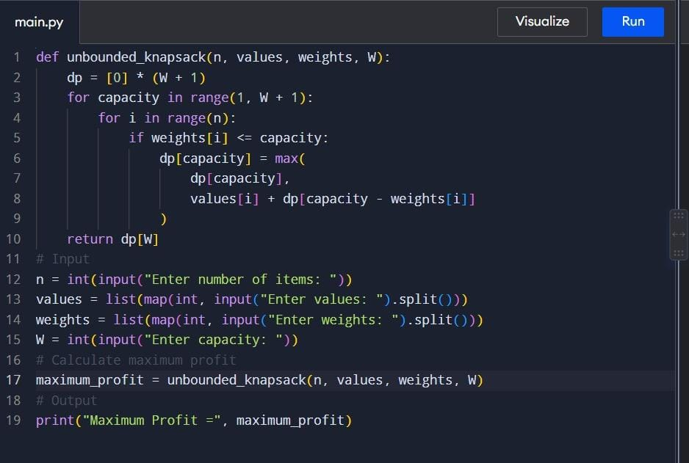

OUTPUT:
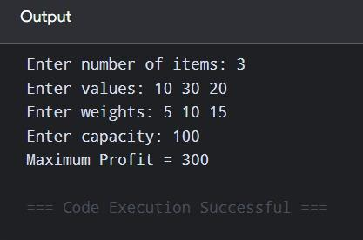

Complexity Analysis:

Case | Complexity
Time Complexity | O(n × W)
Space Complexity | O(W)

Time Complexity:

The outer loop runs for every capacity from 1 to W.

The inner loop checks all n items.

Therefore:

Time Complexity = O(n × W)

For the given problem:

n = 3

W = 100

So the number of main DP iterations is proportional to:

3 × 100 = 300

Space Complexity:

Space Complexity:
Only one DP array of size W + 1 is required.

Therefore:

Space Complexity = O(W)

Result:
The Unbounded Knapsack problem was successfully solved using the Dynamic Programming technique. Since each item can be selected multiple times, the algorithm repeatedly considers the available items for every possible capacity. For the given input, Item 2 with value 30 and weight 10 is selected 10 times, giving a total weight of 100 and a maximum profit of 300.
Thus, the final result is:
Maximum Profit = 300

